
INTELLIGENT SETTLEMENT SYSTEM
A PROJECT REPORT
Submitted by
ALAGAPPAN K (8115U25IT005)
in partial fulfillment of requirements for the award of the course
CGB1201 – JAVA PROGRAMMING
In Department of
INFORMATION TECHNOLOGY

K. RAMAKRISHNAN COLLEGE OF ENGINEERING
(An Autonomous Institution, affiliated to Anna University Chennai and approved by AICTE, New Delhi)
SAMAYAPURAM–621112
NOVEMBER – 2026
K. RAMAKRISHNAN COLLEGE OF ENGINEERING (AUTONOMOUS)
SAMAYAPURAM–621112

BONAFIDE CERTIFICATE
Certified that this project report on “INTELLIGENT SETTLEMENT SYSTEM” is the bonafide work of ALAGAPPAN K (8115U25IT005), Department of INFORMATION TECHNOLOGY, who carried out the project work during the academic year 2026–2027 under the prescribed guidance.
SIGNATURE  Dr. S.Manikandan, M.E., Ph.D.  HEAD OF THE DEPARTMENT  ASSOCIATE PROFESSOR  Department of IT  K. Ramakrishnan College of Engineering (Autonomous)  Samayapuram–621112. | SIGNATURE  Mrs. S.Sathya Priya, M.E., Ph.D.  ASSISTANT PROFESSOR  Department of IT  K. Ramakrishnan College of Engineering (Autonomous)  Samayapuram–621112.
Submitted for the viva-voce examination held on…………….
INTERNAL EXAMINER EXTERNAL EXAMINER

DECLARATION
I declare that the project report on “INTELLIGENT SETTLEMENT SYSTEM” is the result of original work done by me and, to the best of my knowledge, similar work has not been submitted to “ANNA UNIVERSITY CHENNAI” for the requirement of the Degree of BACHELOR OF TECHNOLOGY. This project report is submitted in partial fulfilment of the requirements for the completion of the course CGB1201 – JAVA PROGRAMMING.
Signature
ALAGAPPAN
Register Number: 8115U25IT005
Place: Samayapuram
Date:

ACKNOWLEDGEMENT
It is with great pride that I express my gratitude to our institution “K. Ramakrishnan College of Engineering (Autonomous)”, for providing me with the opportunity to do this project.
I am glad to express my sincere thanks to our honourable Chairman, Dr. K. RAMAKRISHAN, B.E., for providing the facilities during the course of my study in college.
I would like to express my sincere thanks to our beloved Executive Director, Dr. S. KUPPUSAMY, MBA, Ph.D., for his support and for providing adequate time to complete this project.
I would like to thank Dr. D. SRINIVASAN, B.E., M.E., Ph.D., Principal, for giving me the opportunity to carry out this project.
I wholeheartedly thank Dr. S. MANIKANDAN M.E. Ph.D., Head of the Department and faculty members of the Department of INFORMATION TECHNOLOGY for their encouragement and support.
I express my deep gratitude to my project supervisor Mrs. S SATHYA PRIYA M.E. (Ph.D) Department of INFORMATION TECHNOLOGY, for her incalculable suggestions, guidance, creativity, assistance and patience, which motivated me to carry out this project.
I render my sincere thanks to the Course Coordinator and other staff members for providing valuable information during the course.
I also wish to express my special thanks to the officials and lab technicians who rendered their help during the project work.

VISION OF THE INSTITUTION
To achieve a prominent position among the top technical institutions.
MISSION OF THE INSTITUTION
- M1: To bestow standard technical education par excellence through state of the art infrastructure, competent faculty and high ethical standards.
- M2: To nurture research and entrepreneurial skills among students in cutting edge technologies.
- M3: To provide education for developing high-quality professionals to transform the society.
VISION OF DEPARTMENT
To create eminent professionals of Information Technology by imparting quality education.
MISSION OF DEPARTMENT
M1: To provide technical exposure in the field of Information Technology through state of the art infrastructure and ethical standards.
M2: To engage the students in research and development activities in the field of Information Technology.
M3: To empower the learners to involve in industrial and multi-disciplinary projects for addressing the societal needs.
PROGRAM EDUCATIONAL OBJECTIVES
Our graduates shall:
PEO1: Analyse, design and create innovative products for addressing social needs.
PEO2: Equip themselves for employability, higher studies and research.

PEO3: Nurture the leadership qualities and entrepreneurial skills for their successful career.
PROGRAM SPECIFIC OUTCOMES (PSOs)
• PSO1: Apply the basic and advanced knowledge in developing software, hardware and firmware solutions addressing real-life problems.
• PSO2: Design, develop, test and implement product-based solutions for career enhancement.
PROGRAM OUTCOMES (POs)
Engineering graduates will be able to:
1. Engineering knowledge: Apply the knowledge of mathematics, science, engineering fundamentals, and an engineering specialization to the solution of complex engineering problems.
2. Problem analysis: Identify, formulate, review research literature, and analyse complex engineering problems reaching substantiated conclusions using first principles of mathematics, natural sciences, and engineering sciences.
3. Design/development of solutions: Design solutions for complex engineering problems and design system components or processes that meet the specified needs with appropriate consideration for public health and safety, and the cultural, societal, and environmental considerations.
4. Conduct investigations of complex problems: Use research-based knowledge and research methods including design of experiments, analysis and interpretation of data, and synthesis of the information to provide valid conclusions.
5. Modern tool usage: Create, select, and apply appropriate techniques, resources, and modern engineering and IT tools including prediction and modelling to complex engineering activities with an understanding of the limitations.
6. The engineer and society: Apply reasoning informed by the contextual knowledge to assess societal, health, safety, legal and cultural issues and the consequent responsibilities relevant to the professional engineering practice.
vi

7. Environment and sustainability: Understand the impact of the professional engineering solutions in societal and environmental contexts, and demonstrate the knowledge of, and need for sustainable development.
8. Ethics: Apply ethical principles and commit to professional ethics and responsibilities and norms of the engineering practice.
9. Individual and team work: Function effectively as an individual, and as a member or leader in diverse teams, and in multidisciplinary settings.
10. Communication: Communicate effectively on complex engineering activities with the engineering community and with society at large, such as, being able to comprehend and write effective reports and design documentation, make effective presentations, and give and receive clear instructions.
11. Project management and finance: Demonstrate knowledge and understanding of the engineering and management principles and apply these to one’s own work, as a member and leader in a team, to manage projects and in multidisciplinary environments.
12. Life-long learning: Recognize the need for, and have the preparation and ability to engage in independent and life-long learning in the broadest context of technological change.

ABSTRACT
The INTELLIGENT SETTLEMENT SYSTEM is a web-based application designed to help groups manage shared costs and settle outstanding balances in a clear and organized manner. When friends, roommates, classmates, or colleagues share payments, it can be difficult to calculate each person’s contribution and determine who should pay whom. The system addresses this problem by allowing shared expenses to be recorded, participants to be identified, and individual shares to be calculated using equal, percentage-based, or custom splitting methods.
The application brings together user and group management, expense entry, expense splitting, debt simplification, and settlement reporting. After the shares are calculated, the system determines the net balance of each member. A debt-simplification process then matches members who owe money with members who are owed money and recommends a reduced set of settlement transactions. The website presents this information through dedicated screens for groups, expenses, balances, suggested settlements, and reports.
The main aim is to reduce manual calculations, avoid confusion between multiple dues, and make group financial coordination easier to understand. The project demonstrates the use of programming logic, data organization, modular design, and a web interface to address a practical problem. The implementation and its visible screens are documented in the following chapters. Features such as permanent database storage and automated due notifications are treated as future enhancements unless confirmed in the deployed implementation.

ABSTRACT WITH POs AND PSOs MAPPING
The project develops an INTELLIGENT SETTLEMENT SYSTEM to organize shared expenses and simplify financial obligations among group members. It supports group creation, expense recording, configurable cost splitting, net-balance calculation, settlement suggestions, and reporting. By consolidating individual balances and matching debtors with creditors, the system aims to reduce unnecessary transfers and present settlement information clearly through a website.
Project contribution | PO mapping (indicative) | PSO mapping (indicative)
Apply programming and mathematical reasoning to shared-cost calculations | PO1 – High; PO2 – High | PSO1 – High
Design a modular solution for a real-world financial coordination problem | PO2 – High; PO3 – High | PSO1 – High; PSO2 – High
Use software tools and a web interface to present results | PO5 – Medium/High; PO10 – Medium | PSO2 – High
Work through requirements, implementation, testing, and documentation | PO9 – Medium; PO11 – Medium; PO12 – Medium | PSO2 – Medium
Note:

TABLE OF CONTENTS
ABSTRACT viii
ABSTRACT WITH POs AND PSOs MAPPING ix
TABLE OF CONTENTS x
CHAPTER 1 – INTRODUCTION 1
1.1 Objective 1
1.2 Overview 1
1.3 Technologies and Tools Used 2
CHAPTER 2 – PROJECT METHODOLOGY 3
2.1 Problem Definition 3
2.2 Proposed Work 3
2.3 Core Concepts and Data Handling 4
2.4 System Architecture 4
CHAPTER 3 – MODULE DESCRIPTION 5
3.1 User and Group Management Module 5
3.2 Expense Entry Module 6
3.3 Expense Splitting Module 7
3.4 Debt Simplification Module 8
3.5 Settlement and Reporting Module 9
CHAPTER 4 – RESULT AND DISCUSSION 10
4.1 Website Screens and Results 10
4.2 Discussion 13
CHAPTER 5 – CONCLUSION AND FUTURE SCOPE 14
5.1 Conclusion 14
5.2 Future Scope 15
APPENDIX A – WORKFLOW AND TEST CASES 16
APPENDIX B – WEBSITE SCREENSHOTS 17
REFERENCES 20

CHAPTER 1
INTRODUCTION

1.1 Objective
The primary objective of the INTELLIGENT SETTLEMENT SYSTEM is to make shared-cost management and settlement easier for groups. It records expenses, identifies the payer and participants, calculates each participant’s share, and determines the net amount owed by or payable to each member. It also applies debt simplification to recommend a smaller set of transfers that can clear the group’s outstanding balances.
The project has the following objectives:
- Organize users into groups that share expenses.
- Record the expense amount, payer, participants, date, and category where applicable.
- Support equal, percentage-based, and custom expense splitting.
- Calculate each member’s net balance after considering payments and shares.
- Recommend settlement transactions that reduce the number of transfers.
- Present expense history, balances, and settlement summaries through a website.

1.2 Overview
Shared spending is common during trips, meals, accommodation, events, and group activities. A person may pay for an expense on behalf of several people, while other members may pay for different expenses later. Tracking each individual payment manually can result in repeated calculations, unclear balances, and unnecessary back-and-forth transfers.
The system provides a structured workflow. Users and groups are organized first. Expenses are then entered with the payer and participants. The expense-splitting component calculates individual shares, and the balance calculation combines these shares with the amounts paid. The debt-simplification component generates settlement suggestions. Finally, the settlement and reporting section presents the amounts that need to be settled and the overall status.

1.3 Technologies and Tools Used
The project is presented as a website and applies programming logic to the financial workflow. The Java Programming course context is central to the project’s computational logic. A web interface provides the screens for group management, expense entry, expense history, debt simplification, and settlement reporting.
- Java programming concepts: classes, objects, collections, conditional logic, iteration, and methods can be used to represent users, expenses, balances, and settlement operations.
- Web interface: provides forms, tables, navigation, and summaries so users can interact with the project through a browser.
- Development environment: a code editor and browser are used to develop and inspect the application.
- Data storage: permanent database integration is identified as an enhancement in the project presentation; it should be described as implemented only if the final application demonstrably persists data.
The report describes the functions visible in the supplied project presentation and avoids assuming that every proposed enhancement is already active in the running application.

CHAPTER 2
PROJECT METHODOLOGY

2.1 Problem Definition
When several people share costs, the person who pays is not always the person who ultimately bears the expense. For example, one member may pay for accommodation, another may pay for food, and a third may pay for transport. Each expense may involve a different set of participants. Without a consistent method, the group must manually calculate each share and compare it with the amounts already paid.
The problem becomes more difficult when several members owe money to one another. Directly settling every individual expense can create many transfers even when the group’s net balances could be cleared with fewer payments. The project therefore needs to calculate fair shares, aggregate the balances, and generate understandable settlement suggestions.

2.2 Proposed Work
The proposed system follows a modular process. It begins with user and group management, continues with expense entry and share calculation, and then consolidates balances for debt simplification. The result is displayed in settlement and reporting screens.
- Create or select a group and identify its members.
- Enter an expense, its amount, the member who paid, and the members who share it.
- Choose an available split method and calculate each participant’s share.
- Update the group’s net balances using amounts paid and amounts owed.
- Match members with negative balances (debtors) to members with positive balances (creditors) and produce settlement suggestions.
- Display expense history, settlement details, and financial summaries.

2.3 Core Concepts and Data Handling
The application is based on several core concepts:
- User and group records: identify members and the group to which a shared expense belongs.
- Expense record: captures a description, amount, payer, date/category where supported, and participants.
- Expense share: represents the portion assigned to each participant under the selected split method.
- Net balance: represents the difference between the amount a member has paid and the amount that member is responsible for.
- Settlement transaction: represents a suggested or recorded payment between a debtor and a creditor.
For a group, a positive net balance indicates that the member should receive money, while a negative net balance indicates that the member should pay money. A balanced group should have net balances whose sum is zero, subject to rounding rules. Currency calculations should use consistent precision to avoid rounding discrepancies.

2.4 System Architecture
The high-level workflow consists of the website interface, the application logic, and the data handled by the system. The interface accepts group and expense details and displays calculated results. The application logic validates inputs, calculates shares, aggregates balances, and creates settlement suggestions. The data layer represents users, groups, expenses, shares, and settlement records. The exact persistence mechanism depends on the final deployed implementation.
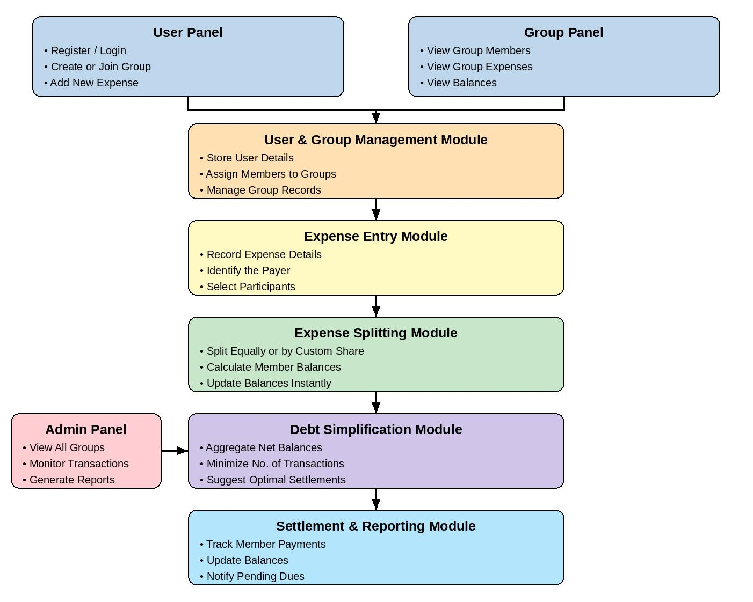
Figure 2.1: Architecture diagram from the project presentation.

CHAPTER 3
MODULE DESCRIPTION

3.1 User and Group Management Module
The User and Group Management Module organizes the people who participate in shared spending. It provides the foundation for all other modules because expenses and balances must be associated with the correct group members.

3.1.1 User Registration and Management
User records identify members through their details, such as a user ID and name. Managing these records reduces ambiguity when an expense is assigned to a payer or participant. The system should ensure that each expense refers to members who exist in the relevant group.

3.1.2 Group Creation and Member Management
A group represents a set of people who share costs. Members can be added to a group and displayed together so that they can be selected during expense entry. Examples include classmates sharing food costs, friends travelling together, or roommates sharing household bills.
The module’s main output is a clearly identified group and its member list. These records are used by the expense-entry and expense-splitting modules.
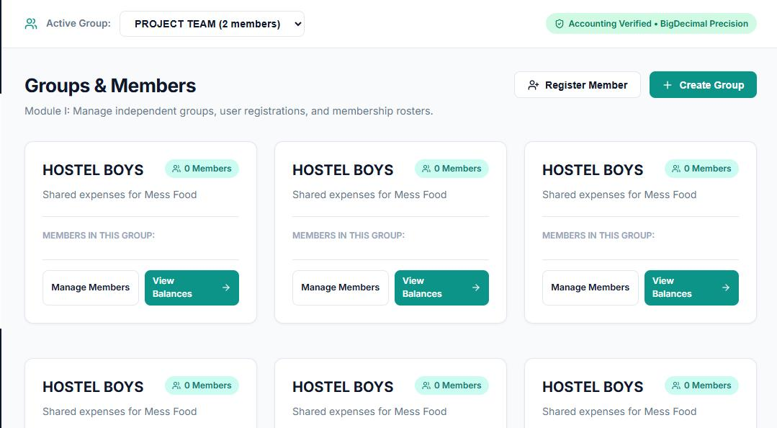
Figure 3.1: Website screenshot – group and member management.

3.2 Expense Entry Module
The Expense Entry Module records the details of a shared purchase or payment. It captures the information needed to calculate each participant’s responsibility and preserve an understandable history of group spending.

3.2.1 Expense Recording
The user enters the expense description and amount, selects the payer, and provides the other supported details such as date, category, and participants. The payer is the member who initially paid the full amount. The participants are the members who should share the cost.

3.2.2 Participant Selection and Expense History
Participant selection is important because not every member necessarily shares every expense. The expense history screen allows users to review recorded entries and check details rather than relying on memory or separate notes.
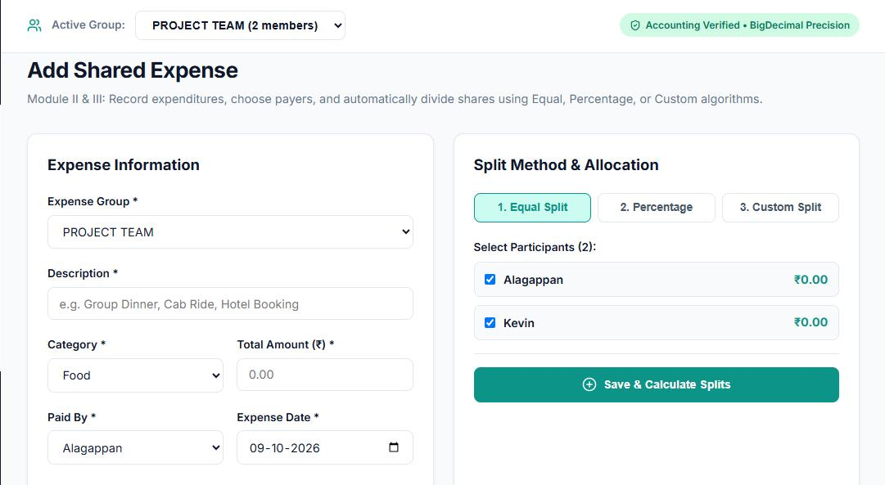
Figure 3.2: Website screenshot – adding a shared expense.
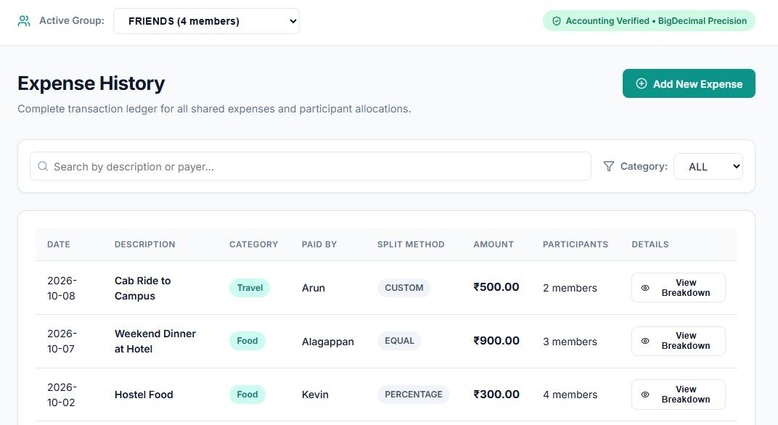
Figure 3.3: Website screenshot – expense history.

CHAPTER 3 (CONTINUED)

3.3 Expense Splitting Module
The Expense Splitting Module calculates how much of an expense belongs to each selected participant. It separates the person who paid the expense from the people who are responsible for sharing it. This distinction is necessary for accurate balance calculation.

3.3.1 Equal Split
In an equal split, the total amount is divided evenly among the selected participants. If an expense of ₹1,200 is shared by four members, each member’s share is ₹300. The payer’s own share is included when the payer is also a participant.

3.3.2 Percentage-Based Split
In a percentage-based split, each participant is assigned a specified percentage of the total amount. The percentages should add up to 100%. For an expense of ₹1,000, shares of 50%, 30%, and 20% correspond to ₹500, ₹300, and ₹200.

3.3.3 Custom Split
A custom split allows the user to specify an individual share for each participant. The entered shares should add up to the total expense amount. Validation is important so that an incorrect allocation does not create misleading balances.

3.3.4 Balance Calculation
After the shares are calculated, the system compares the responsibility of each member with the amounts that member paid. The resulting net balance indicates whether the member should receive money or pay money. This balance becomes an input to the debt-simplification process.
Figure 3.4: Expense entry screen associated with the splitting workflow.

3.4 Debt Simplification Module
The Debt Simplification Module is the key computational feature of the project. Instead of asking every member to settle every expense separately, it combines the individual net balances and recommends a smaller set of transfers that clears the same overall obligations.

3.4.1 Balance Aggregation
The module first obtains the net balance of each group member. Members with negative balances are debtors; members with positive balances are creditors. Members whose balances are zero do not need to make or receive a payment for the current set of expenses.

3.4.2 Greedy Settlement Strategy
A common greedy strategy repeatedly selects a debtor with an outstanding amount and a creditor who is owed money. It recommends a transfer equal to the smaller of the debtor’s amount owed and the creditor’s amount due. That amount is deducted from both outstanding balances. The process repeats until all balances are cleared or the remaining values are within the accepted rounding tolerance.
This method produces a valid simplified settlement plan and is efficient for a small group. It should be described as a greedy minimization strategy rather than a guarantee of a globally optimal solution for every possible variant of the problem.

3.4.3 Settlement Suggestions
The output is a list of suggested payments, each identifying the member who should pay, the member who should receive the money, and the amount. These are recommendations derived from the net balances; they should not automatically be treated as completed payments.
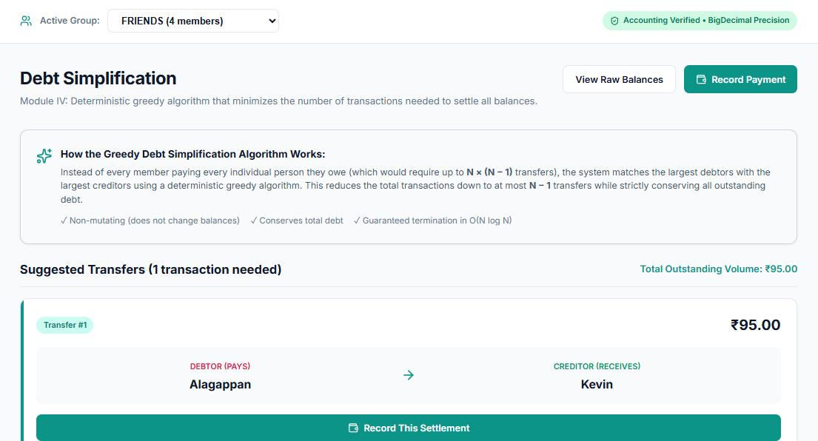
Figure 3.5: Website screenshot – debt simplification and suggested settlements.

CHAPTER 3 (CONTINUED)

3.5 Settlement and Reporting Module
The Settlement and Reporting Module presents the result of the balance calculations in a form that group members can understand. It supports reviewing who owes whom, how much is involved, and whether outstanding dues remain.

3.5.1 Settlement Tracking
A settlement represents a payment made to clear an outstanding obligation. The system should distinguish between a suggested transaction and a payment that has actually been recorded. A balance should be marked as settled only after the corresponding payment is confirmed by the application’s workflow.

3.5.2 Balance Updating and Report Generation
After a recorded settlement, the relevant outstanding balances should be updated consistently. Reports summarize the group’s financial position, including expenses, net balances, suggested or completed settlements, and remaining dues where those details are available.

3.5.3 Due Status
Pending status helps users identify obligations that have not yet been cleared. Automated notifications are listed as a future enhancement in the project presentation; therefore, they should only be claimed as an implemented feature if the website actually sends such notifications.
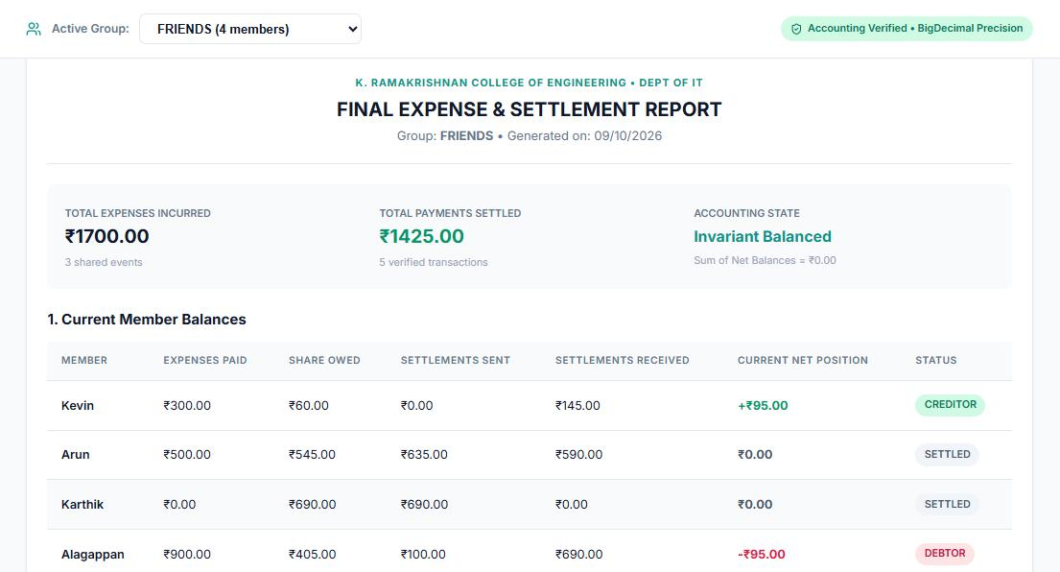
Figure 3.6: Website screenshot – final expense and settlement report.

CHAPTER 4
RESULT AND DISCUSSION

4.1 Website Screens and Results
The project presentation includes screenshots of the website’s main workflows. They illustrate how the user interface is organized around group management, expense entry, expense history, debt simplification, and reporting.

4.1.1 Group and Member Management
The group screen presents groups and their members, giving the user a starting point for selecting the people involved in shared spending. This supports the requirement to organize users before recording expenses.
Figure 4.1: Group and member management screen.

4.1.2 Add Shared Expense
The expense-entry screen provides fields for entering shared-cost information and selecting a split method. This screen is the input point for the calculations performed by the later modules.
Figure 4.2: Add shared expense screen.

4.1.3 Expense History
The expense-history screen displays previously entered expense records in a table format. A history view helps users review transactions and understand which records contribute to the group’s balance.
Figure 4.3: Expense history screen.

4.1.4 Debt Simplification
The debt-simplification screen presents the group’s balance information and recommended transfers. This is the main screen that distinguishes the project from a basic expense tracker: the goal is not only to record spending but also to simplify the settlement of obligations.
Figure 4.4: Debt simplification screen.

4.1.5 Final Expense and Settlement Report
The final report screen summarizes expense and settlement information in a consolidated view. It supports a clearer understanding of the group’s financial status.
Figure 4.5: Final expense and settlement report.

4.2 Discussion
The project follows a logical sequence from group setup to expense recording, share calculation, balance aggregation, debt simplification, and reporting. Separating these responsibilities into modules makes the system easier to explain, test, and maintain. The interface screenshots also show how the project’s computations are presented to users.
The correctness of the application depends on maintaining consistent rules across all modules. Participant shares should equal the expense total; each expense must be associated with the correct payer and group; and the sum of the group’s net balances should be zero apart from rounding differences. Suggested transfers should clear the outstanding net balances without changing the original expense history.
The screenshots demonstrate the intended user-facing workflow, but they do not by themselves prove every backend or persistence behavior. Features such as authentication, permanent database storage, automated reminders, and actual payment processing should be reported as implemented only when verified in the running system.

CHAPTER 5
CONCLUSION AND FUTURE SCOPE

5.1 Conclusion
The INTELLIGENT SETTLEMENT SYSTEM addresses the practical difficulty of managing shared costs among a group of people. It organizes members into groups, records expenses, calculates individual shares, determines net balances, and recommends settlement transactions. The debt-simplification feature reduces the need to settle every expense separately and presents a clearer way to resolve group obligations.
The project combines financial calculation logic with a website interface that presents the workflow through group management, expense entry, expense history, debt simplification, and reporting screens. Its modular structure makes the main functions easier to understand and provides a foundation for further development. The project’s primary contribution is the transformation of scattered shared expenses into a consolidated and actionable settlement plan.

5.2 Future Scope
- Database integration: persist users, groups, expenses, shares, balances, and settlement records between sessions.
- Authentication and access control: allow users to sign in and restrict group data to authorized members.
- Improved validation: check amounts, group membership, split percentages, custom shares, duplicate records, and rounding differences.
- Settlement confirmation: allow a user to mark a suggested payment as paid only after confirmation, with a timestamp and transaction history.
- Automated due notifications: send reminders for outstanding balances through supported notification channels.
- Exportable reports: generate PDF or spreadsheet summaries for group expenses and settlement history.
- Additional split rules: support weighted shares or item-level splitting where required.
- Mobile responsiveness and accessibility: improve the interface for phones, tablets, keyboard navigation, and assistive technologies.
- Testing and reliability: add unit tests for equal, percentage, and custom splits, as well as debt simplification and settlement updates.
These items are proposed extensions. Their inclusion in future scope does not imply that they are already available in the current website.

APPENDIX A
WORKFLOW AND VALIDATION TEST CASES
The following test cases can be used to verify the central calculations of the system. Actual pass/fail results should be recorded after running each case against the final implementation.
Test case | Input / scenario | Expected outcome | Purpose
Equal split | ₹1,200 shared equally by 4 members | ₹300 share per member | Verify equal allocation
Percentage split | ₹1,000 split 50%, 30%, 20% | ₹500, ₹300, ₹200 | Verify percentage calculation
Custom split | ₹900 shares entered as ₹200, ₹300, ₹400 | Shares total ₹900 | Verify custom total
Invalid percentage | Percentages total 90% | Reject or request correction | Prevent incomplete allocation
Net balance | One member pays more than their share | Positive balance for payer if owed money | Verify paid-versus-share logic
Debt simplification | Two debtors and two creditors | Suggested transfers reduce all net balances to zero | Verify matching process
Settlement status | Suggested payment not yet confirmed | Remain pending | Separate suggestion from payment
Completed settlement | Valid payment recorded | Relevant outstanding amount reduced | Verify settlement update

APPENDIX B
WEBSITE SCREENSHOTS
The screenshots below are reproduced from the project presentation and document the visible user interface.
Figure B.1: Group and member management.
Figure B.2: Add shared expense.
Figure B.3: Expense history.
Figure B.4: Debt simplification.
Figure B.5: Final expense and settlement report.

REFERENCES
- Oracle. Java Documentation. https://docs.oracle.com/en/java/
- MySQL. MySQL Reference Manual. https://dev.mysql.com/doc/
- W3Schools. Java Tutorial. https://www.w3schools.com/java/
- GeeksforGeeks. Greedy Algorithms and related programming concepts. https://www.geeksforgeeks.org/
- Google Scholar. Research literature on expense sharing, debt settlement, and transaction minimization. https://scholar.google.com/
- Project presentation: “Expense Splitter with Debt Simplification,” prepared for CGB1201 – Java Programming, K. Ramakrishnan College of Engineering.

